**TOTAL FRAMES IN THE MINI APP**

Overall , the mini project "**Employee Management System**" , will have following frames for the following purposes:

**1. Allowing the user to make selection**

**2. Add New Employee**

**3. Search Details Of An Employee**

**4. View Details Of All Employee**

**5. Update An Employee Details**

**6. Delete An Employee**

To fulfil the above requirements , you have to design the following classes . Make sure you give the names exactly as shown below:

You just have to design these screens . The coding will be discussed in the class

**1.** Design the **OptionsFrame** UI to look as shown below:

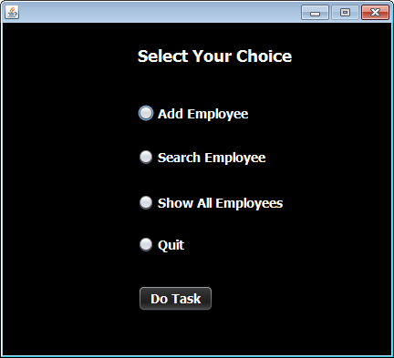

**2.** Design the **AddEmployeeFrame** UI to look as shown below:

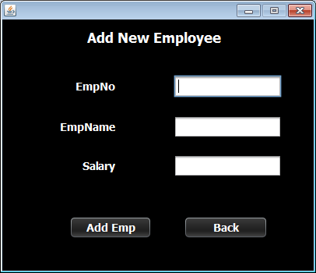

**3.** Design the **SearchEmployeeFrame** UI to look as shown below.

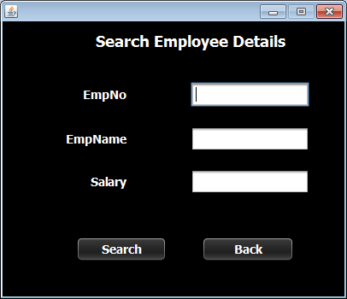

**4.** Design the **ViewAllEmployeeFrame** UI to look as shown below.

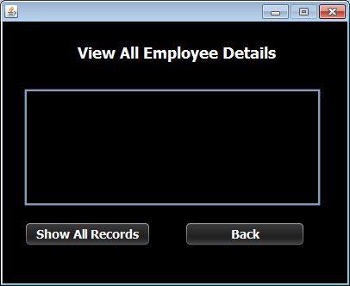

Remaining 2 frames will be given as exercise at the end of the Mini Project

**STEPS TO BE DONE IN** **OptionsFrame**

In the **OptionsFrame** we need to do following steps:

1. Detecting which **RadioButton** user has clicked

2. Opening the respective Frame

3. Disposing the current Frame

**DETECTING WHICH RADIOBUTTON IS SELECTED**

1. The **JRadioButton**  object has a method called **isSelected( )** which returns **true** if the **JRadioButton** is selected otherwise it returns **false**.

2. So to detect whether **jrbAddEmp** is selected or not we would write:

***if(jrbAddEmp.isSelected( ))***

***{***

***}***

**OPENING ANOTHER FRAME FROM CURRENT FRAME**

1. Create an object of the frame to be opened. For ex if you want to open **AddEmployeeFrame** then:

***AddEmployeeFrame addEmpFrame=new AddEmployeeFrame();***

2. Call the method **setVisible( )** of the **JFrame** so that it becomes visible:

***addEmpFrame.setVisible(true);***

3. Call the method **dispose()** of current frame so that it becomes invisible:

***this.dispose();***